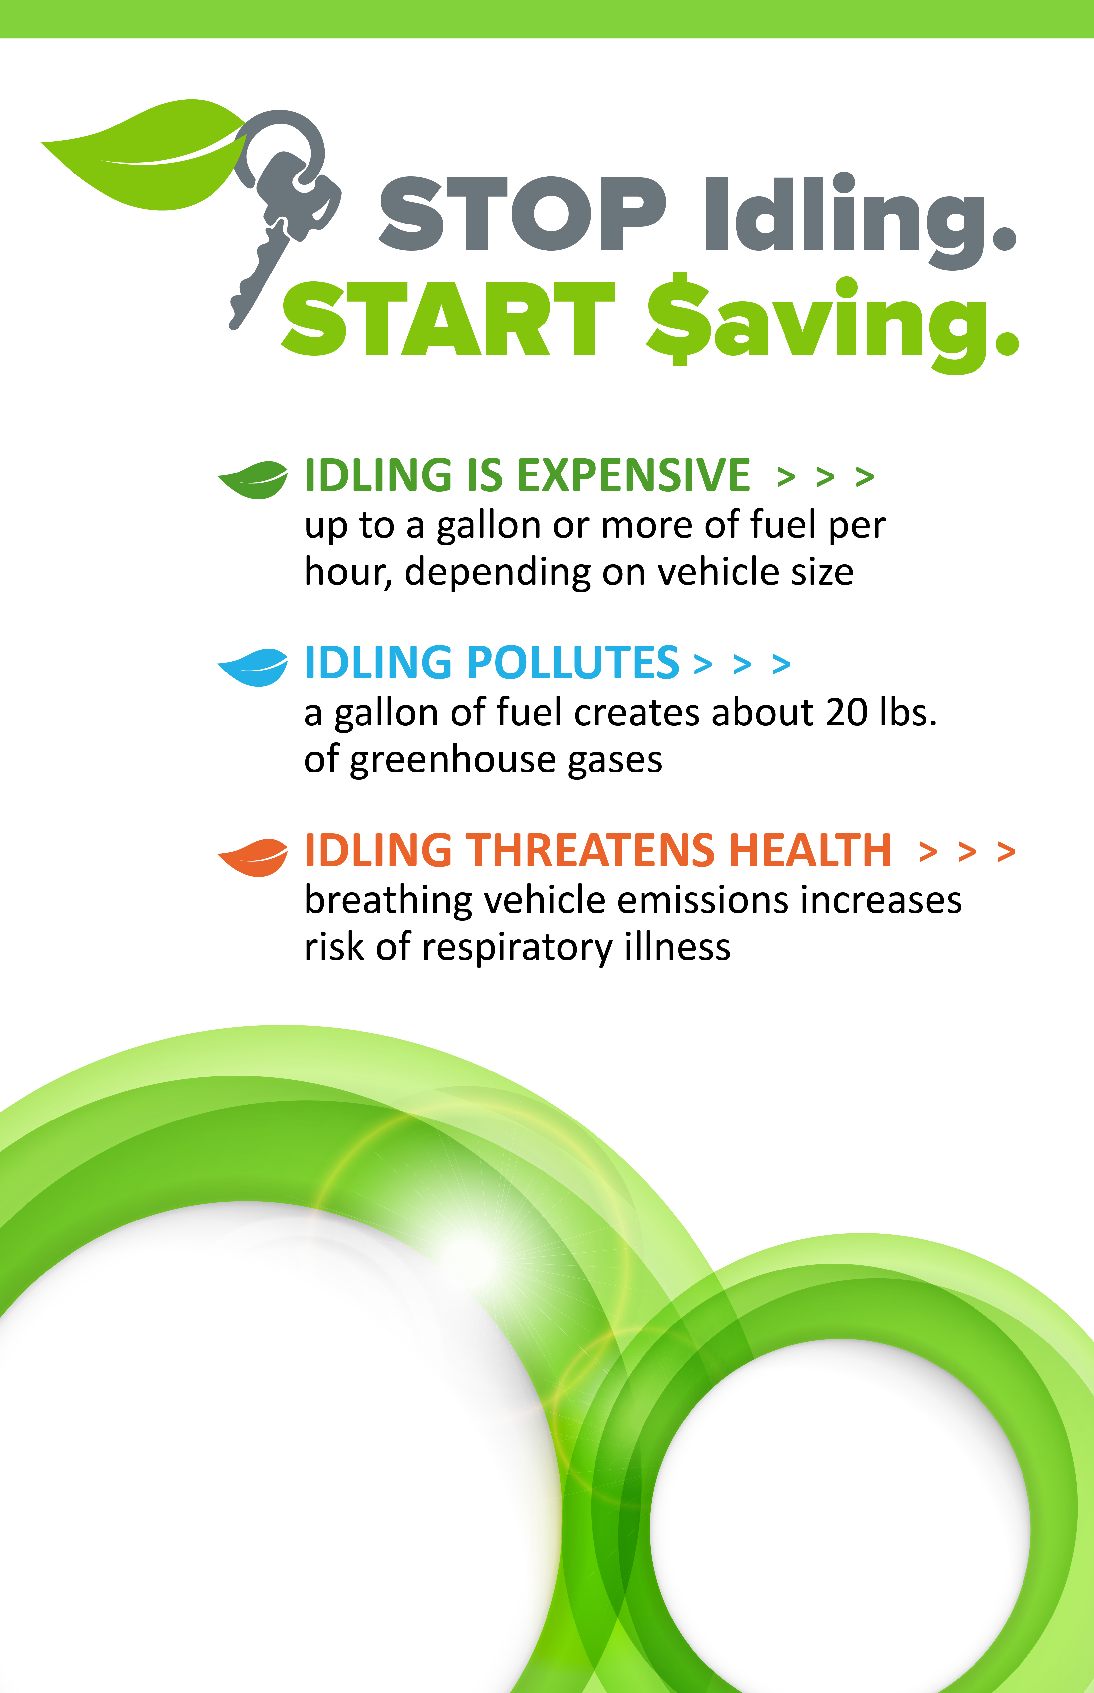

**Idling uses   
more fuel than restarting your engine**

**•**

**Idling wastes   
6 BILLION GALLONS   
OF FUEL each year   
in the U.S.**